**LA GRANDEE INTERNATIONAL COLLEGE**

**Simalchour – 8, Pokhara**

ASSIGNMENT-1

WEB TECH-II

Name: Anish Paudel

Roll no: 4

Git hub repository: https://github.com/anishpaudel225/Web-tech-

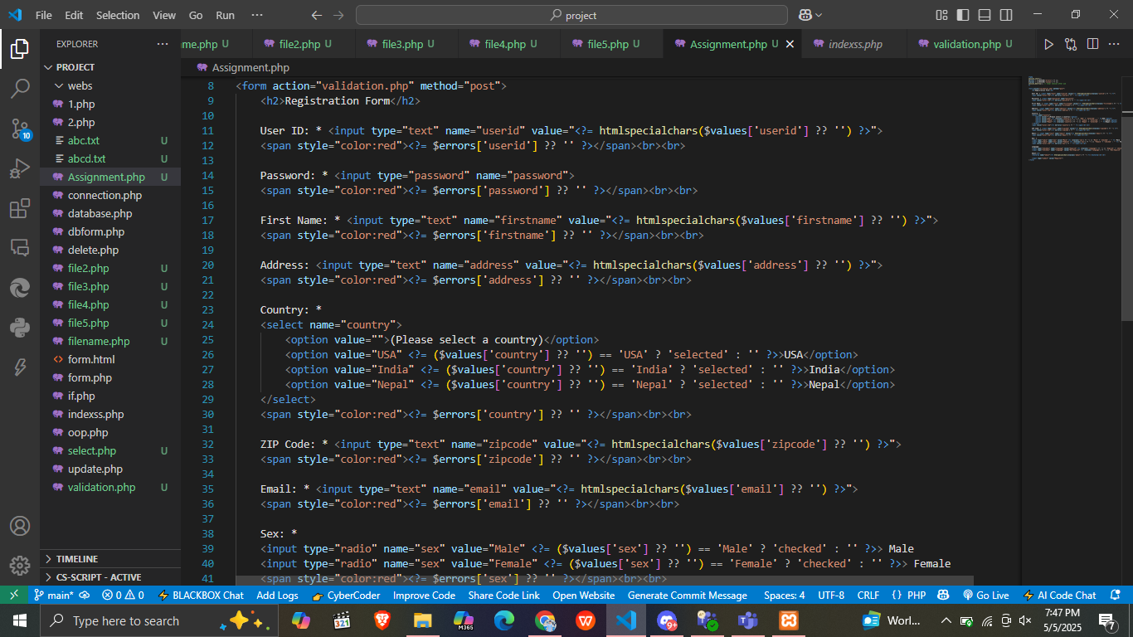HTML form

* 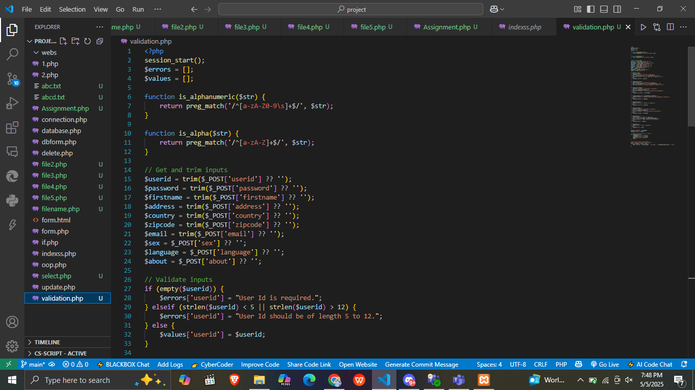Validation code using PHP

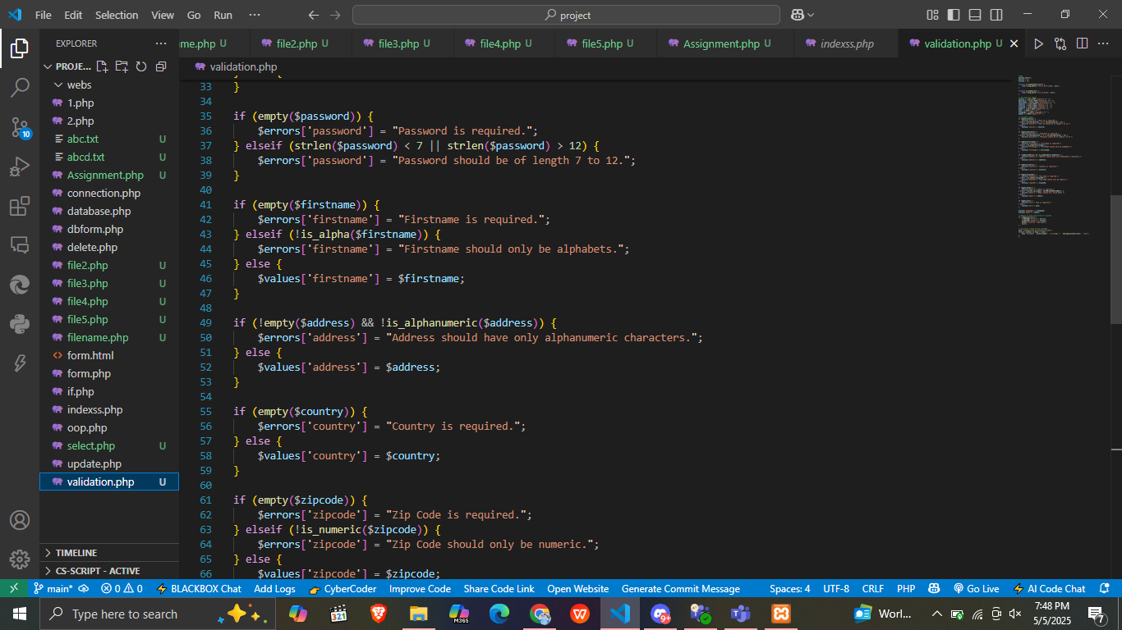

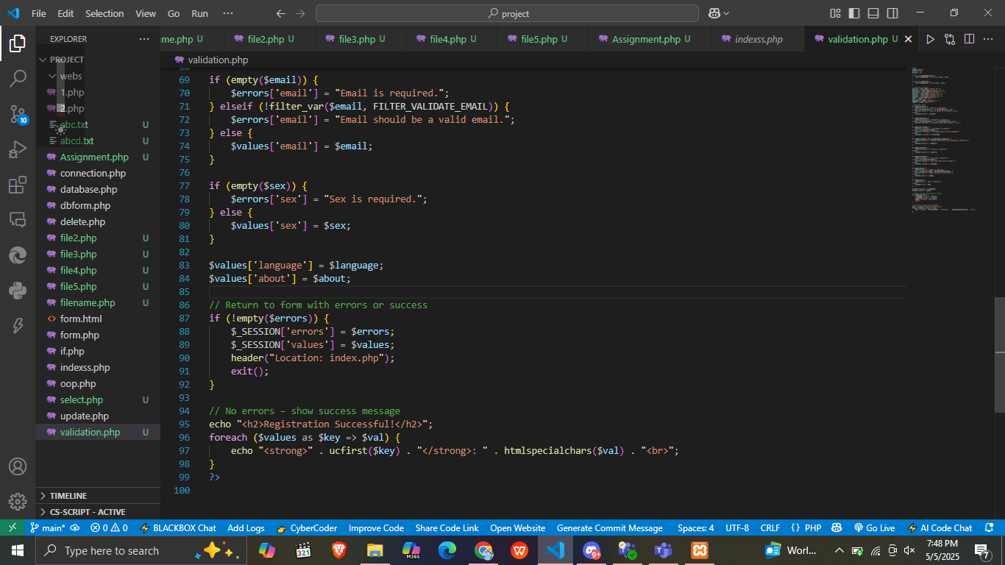

* 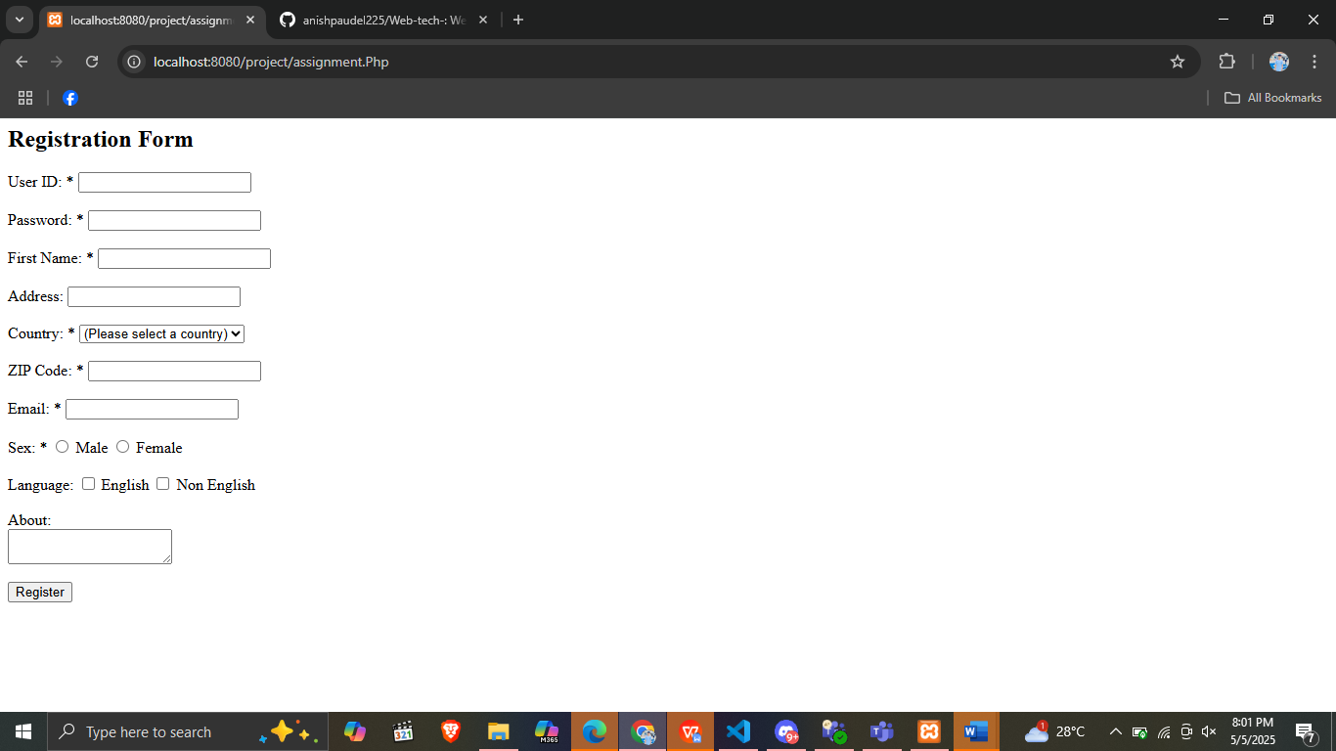Output form
* 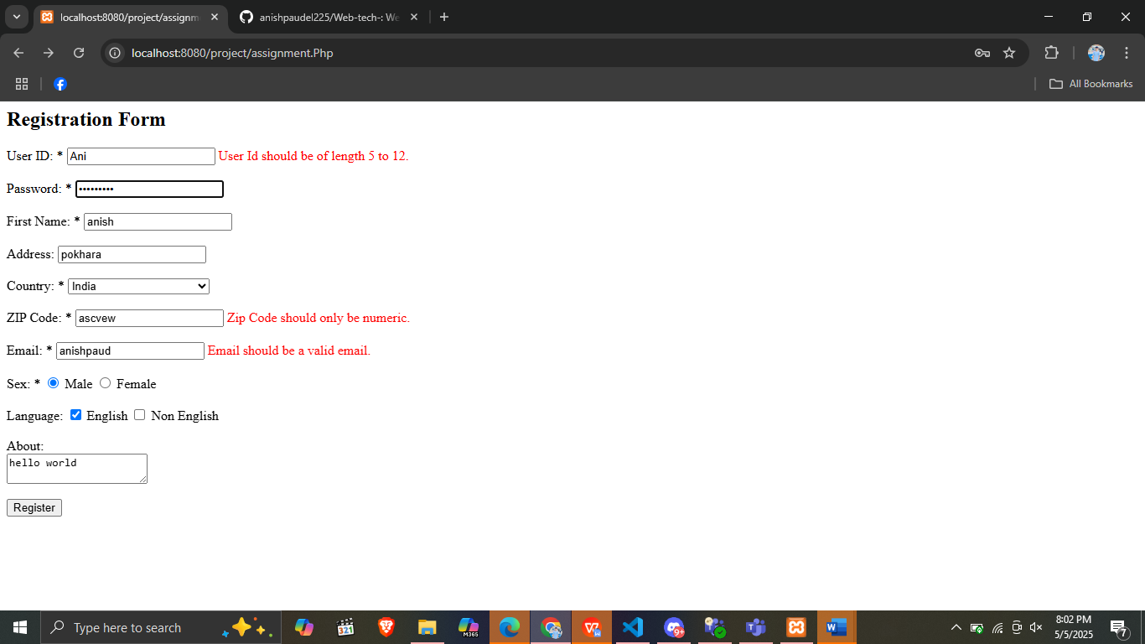Validation Error occur